DHI Net Zero Principles & Goals:

DHI’s approach to leadership, accountability and collective action on Net Zero

Introduction
This document outlines the principles and goals which underpin DHI’s Net Zero policy and its approach to associated partnerships, projects, and operational processes.

The DHI principles and goals are anticipated to be of value internally and externally, with the iterative learning from DHI’s journey on reducing carbon emissions being used to drive changes in its operational processes, and also inform an engaging and inspirational ‘call to arms’ for Scotland’s wider digital health and care ecosystem.

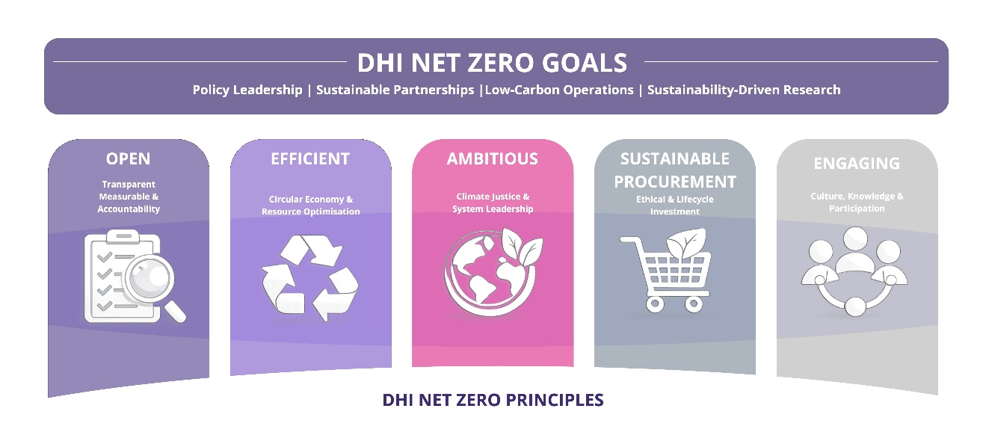

Net Zero Principles
The following principles guide DHI's approach to contributing to Scotland’s Net Zero target and reducing its own carbon emissions:
- Open: Track and report Scope 1, 2, and 3 emissions, including business travel, digital footprint, home working.
- Efficient: Prioritise reuse, refurbishment, and recycling of digital and office equipment as part of its contribution to waste management and the circular economy.
- Ambitious: Embed climate justice and social equity into all DHI operations, research and projects.
- Sustainable Procurement: Align procurement with lifecycle sustainability and ethical investment principles.
- Engaging: Provide regular staff training and encourage participation in sustainability networks and activities. Disseminate learning and support knowledge exchange.

Net Zero Goals
DHI's Net Zero Goals are structured across its policy, partnership, project and operational domains:

Policy:
- Develop and annually review a DHI Net Zero Best Practice framework, to inform policy recommendations across its areas of activity.
- Publicly report progress annually

Partnership
- Align funding applications with sustainability and ethical investment criteria.
- Monitor sustainability-related funding and project outcomes for net zero impact e.g. emissions reduction, resource efficiency, and societal value.

Project and research goals
- Embed sustainability KPIs in project plans and closure documentation.
- Include Net Zero themes in MSc/PhD research and student electives.
- Create a benefits realisation format to track sustainability outcomes.

Operational
- Complete and publish regular carbon emissions performance, following publication of initial footprint for 2024-25.
- Develop a series of guidance notes to improve Scope 3 operational efficiency e.g. Sustainable Travel guidance, Low Carbon Home Working Guidance, Event Management Guidance.

